3rd OPEN CALL MuralartUM 2021 – Subways

for professional artists, art groups and graphic designers, September 6, 2021.
The Prague City Gallery, together with the Technical Road Administration of Prague, announces the open call for proposals of temporary streetart interventions and large paintings for selected subways managed by the Technical Road Administration. The objective of the call is to enhance and cultivate the specific public spaces, and to support positive confrontation with local residents and people passing by. The aim is to broaden the strategic approach of the city and city organizations to the public space management, to improve their coordination, and to raise the public interest in contemporary art.

The realization of the winning projects is planned in 2021 and 2022.

LOCATIONS/AREAS:
- Artistic concept of the front wall of the subway leading to Thomayer Hospital, Prague 4.
- Artistic concept of the whole subway near the bus stop V Sedlci, Prague 6.
- Artistic concept of the ramps and walls near the subway near the bus stop Dědinova, Prague 11.
- Artistic concept of the whole subway near the bus stop Platónova, Prague 12.
- Artistic concept of the whole subway on Svatojánská Street, Prague 14.
- Artistic concept of the whole subway under Makovského Street, Prague 17.

TARGET AUDIENCE OF THE CALL:
- Artists, artist groups, graphic designers.
- The call is non-anonymous, open to everyone.

TERMS AND CONDITIONS FOR APPLICATIONS:
- Please submit the completed application forms with required attachments until October 6, 2021 (the deadline is midnight) to the following addresses:
umenipromesto@ghmp.cz and anna.gumplova@ghmp.cz
- Only one proposal, with the appropriate application form and required attachments, can be submitted per location / area.
- Preferred are documents in PDF or JPG formats, with attachments below 10 MB.

PROPOSAL PARAMETERS:
- Concept proposal / vision of the work in the area (text, max. 500 characters).
- Proposal of an art intervention in the print quality, at least A2 format (sketch, study, project documentation or computer visualization).

REQUIRED ATTACHMENTS TO THE PROPOSAL:
- Application form
- Portfolio with examples of the author’s approach to the public space
- Detailed budget.

PROJECT TOPICS (MuralartUM 2021):
- The MuralartUM project has no fixed topics defined. The artistic intention and idea should, however, always correspond to the specific nature of the location.
- Most emphasis is put into the understanding of the essence of the place, in the context of the urban environment, responding to the spatial functions and social and historical relations in the location.
- The project also attempts at making links to the current mural art issues in global urban centers, at the reflection of streetart and graffiti tendencies in creating the public space, and at improving the awareness of the urban art in the Czech capital.

MORE INFORMATION ON THE MuralartUM 2021 PROJECT:
- The 3rd call is made for six subways. An application form must be submitted for each location separately. There can be max. 6 application forms per participant.
- The essential assessment criteria will be the quality and originality of the proposed intervention.
- All proposals must respect the principles of the open and democratic society.
- No maximum size of the artwork is defined. The sensitive integration into the surroundings is expected. No part of the project can cause any hazard to the public or transport.
- The financial reward will be provided for three of the best proposals for each subway, based on the Committee verdict.

SPECIFICATION OF THE CALL FOR EACH SUBWAY:
- Artistic concept of the front wall of the subway leading to Thomayer Hospital, Prague 4.
Most of the subway leading to the main gate of Thomayer Hospital is clad in tiles. Therefore, the best part for an artistic intervention is the plastered front wall near the entrance. The artwork can overlap to the tiles but should not cover the inner walls of the subway.

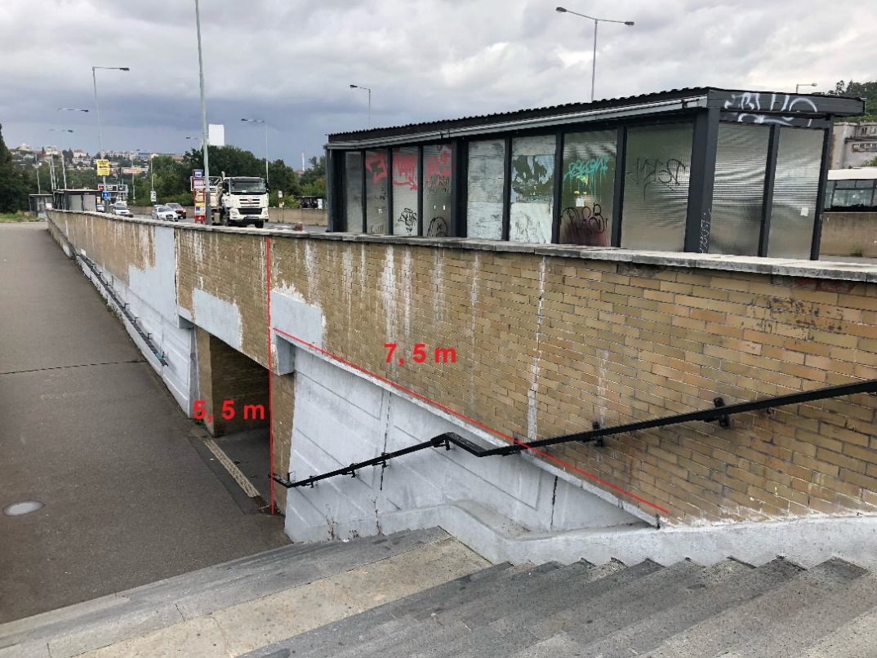
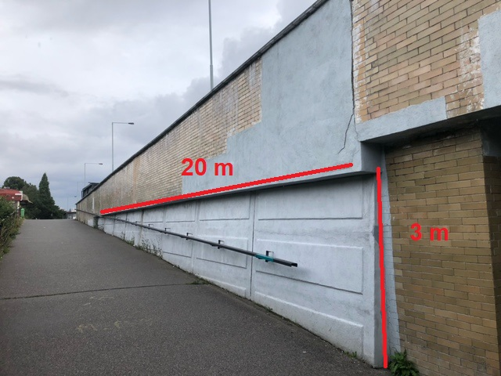
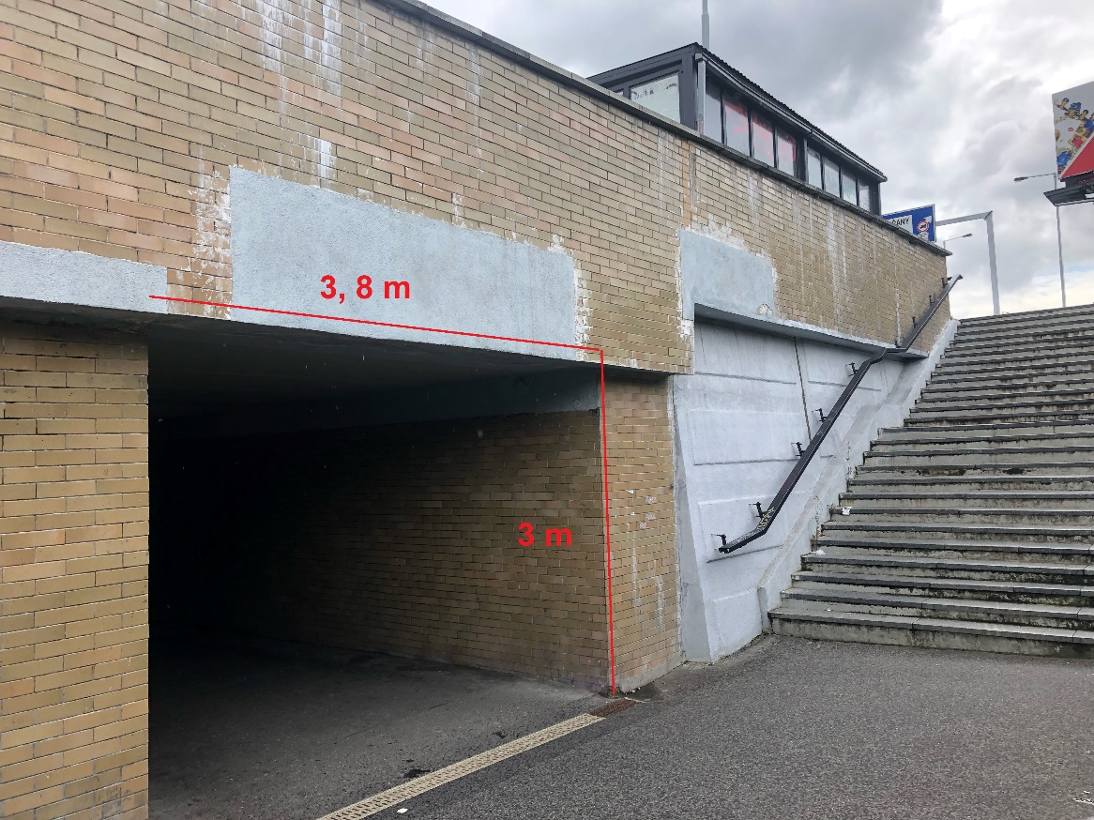

Rewards:
1st place – 15,000 Czk
2nd place – 10,000 Czk
3rd place – 5,000 Czk

- Artistic concept of the whole subway near the bus stop V Sedlci, Prague 6.
The subway under Kamýcká Street near the bus stop V Sedlci connects the busy street with the natural reserve Sedlec Orchard and the meander of the Vltava River. Both the front wall and the inner subway are suitable for artworks.

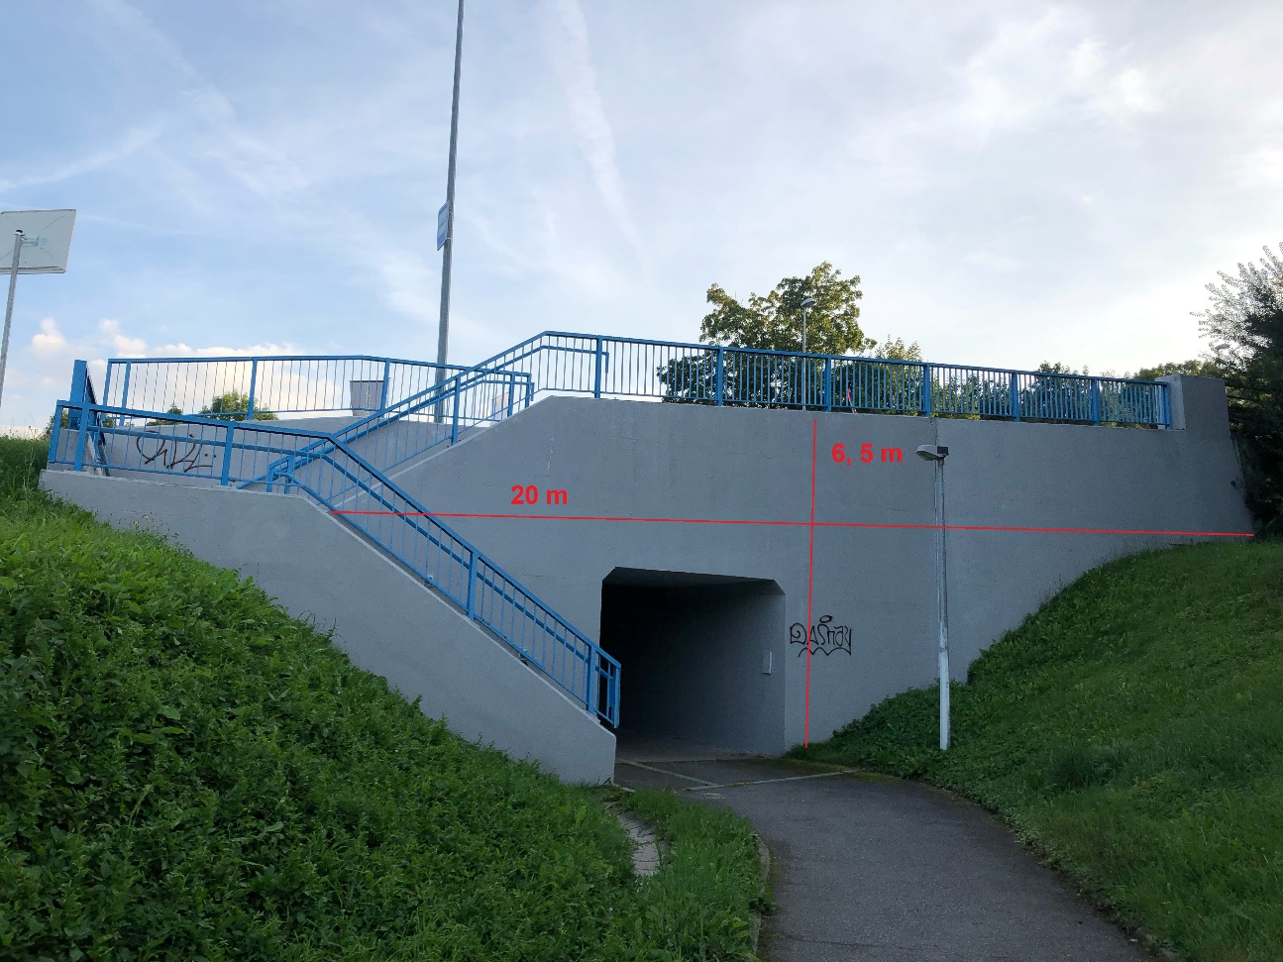

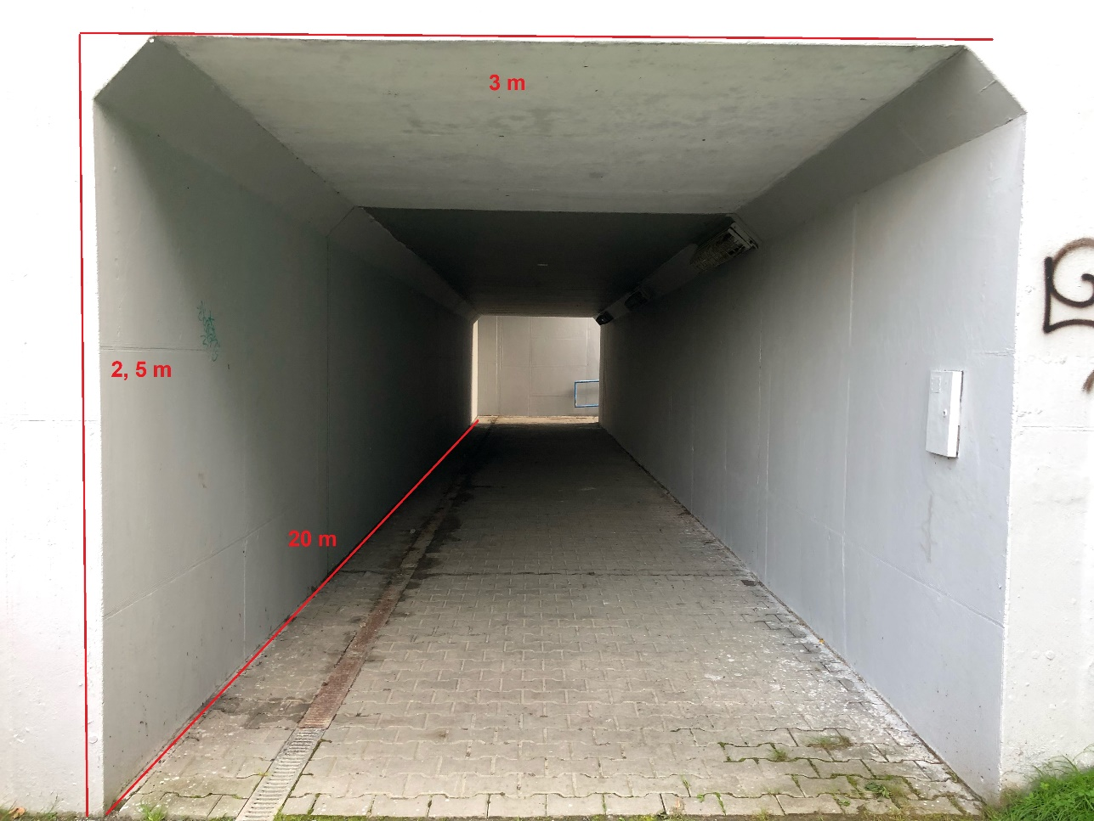

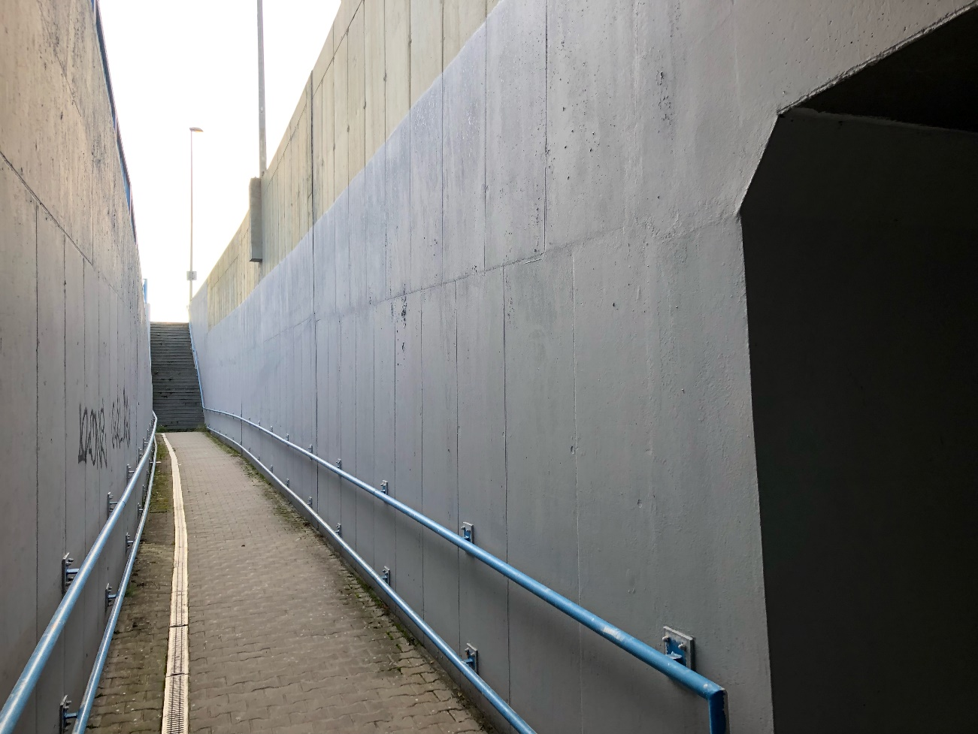

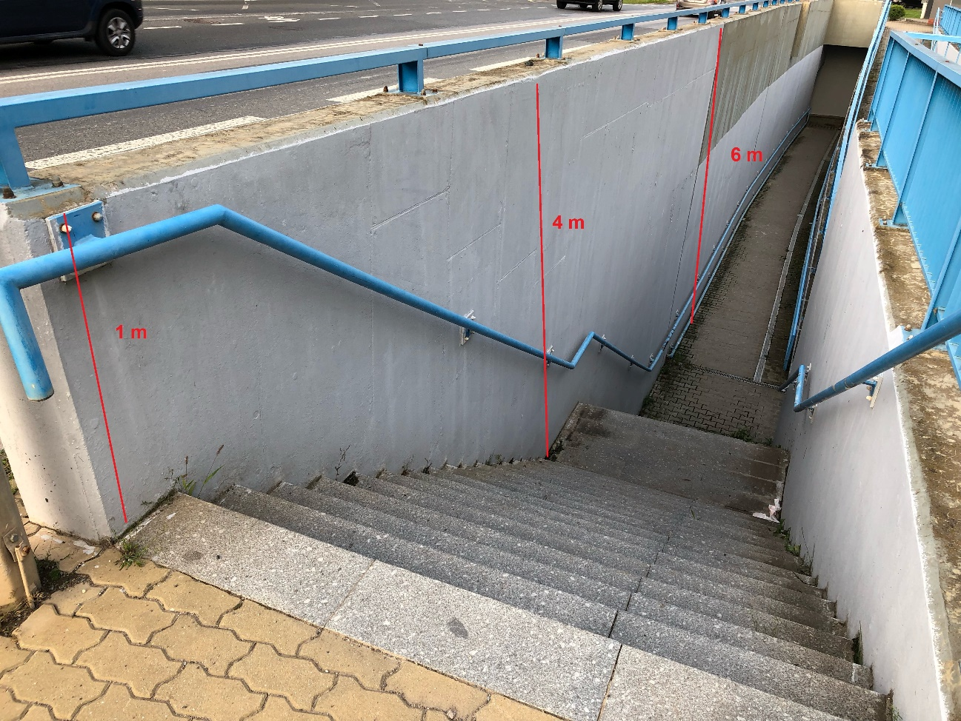

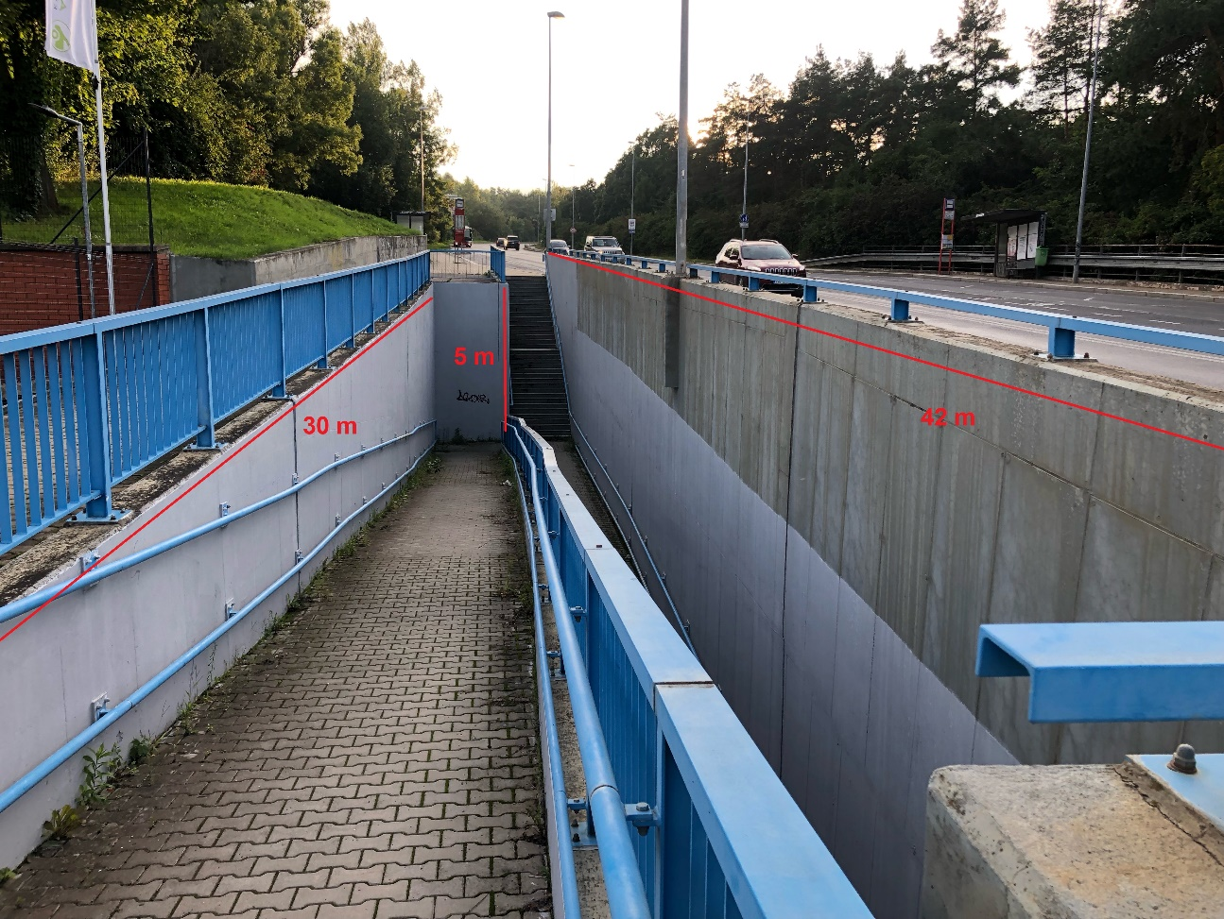
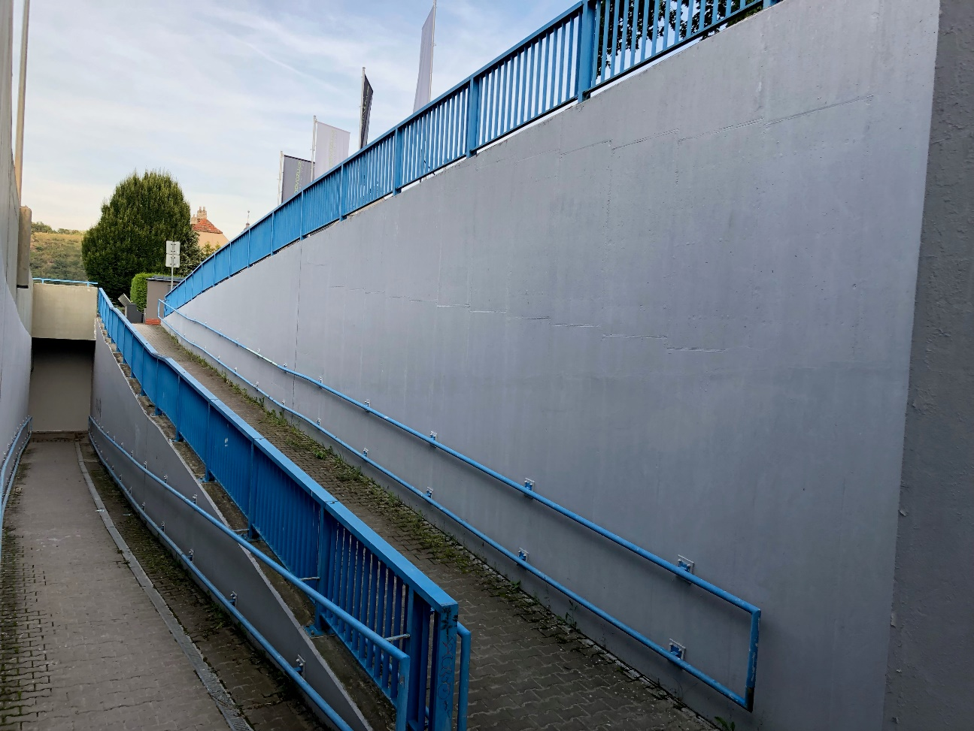

Rewards:
1st place – 30,000 Czk
2nd place – 20,000 Czk
3rd place – 10,000 Czk

- Artistic concept of the ramps and walls near the subway near the bus stop Dědinova, Prague 11.
One of the biggest subways in the Czech Republic features a vast system of ramps and walls. The artistic intervention is most wanted in the areas around the subway, since the subway itself has been recently painted by children from the local primary school, and the municipality wishes to keep these paintings. The intervention can follow up on the children’s paintings, or interact with pedestrians walking from / to bus stops and between the blocks of flats.

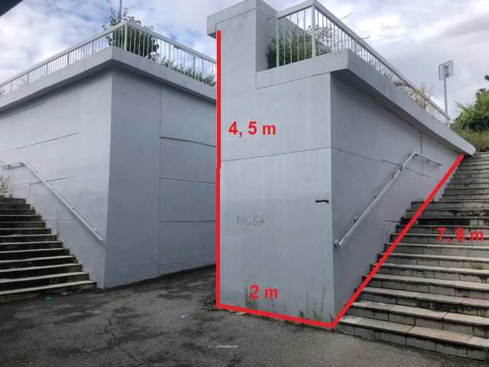

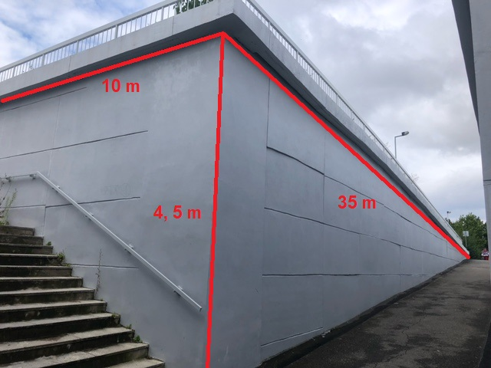

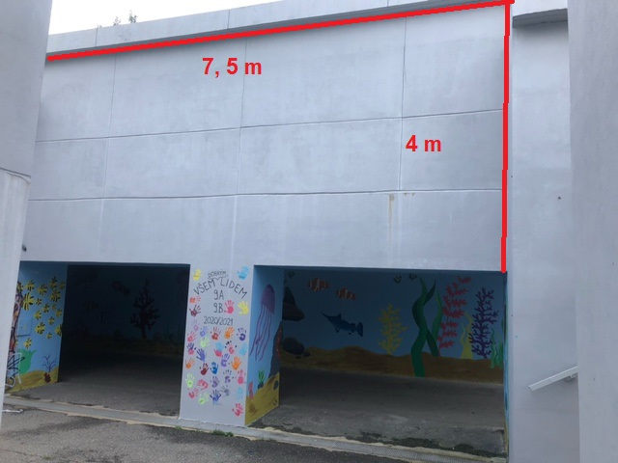
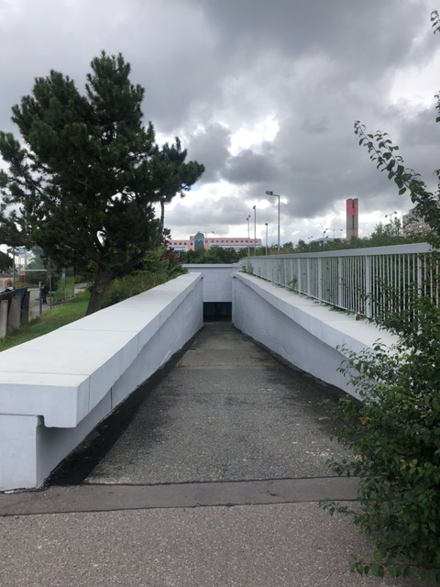
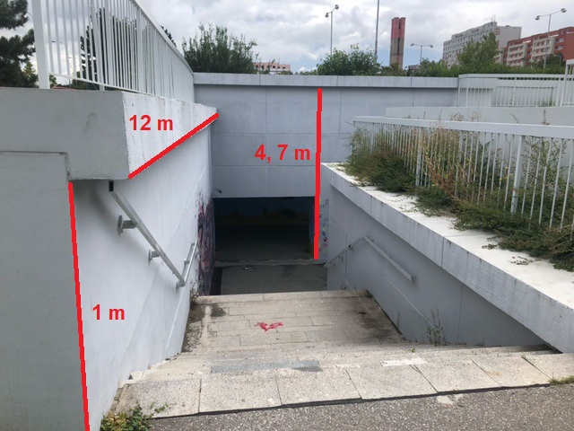

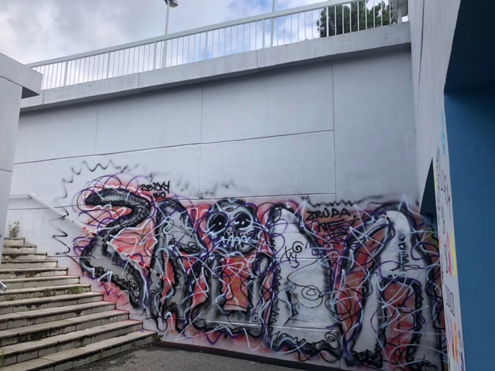

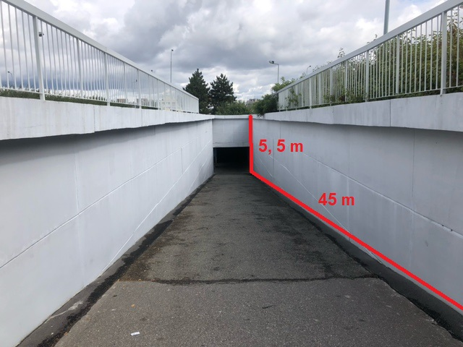

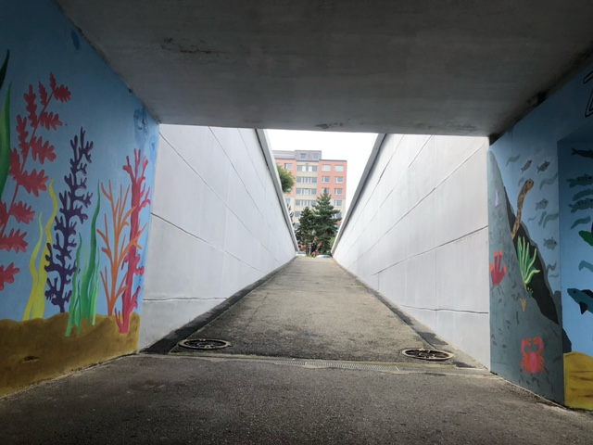

Rewards:
1st place – 30,000 Czk
2nd place – 20,000 Czk
3rd place – 10,000 Czk

- Artistic concept of the whole subway near the bus stop Platónova, Prague 12.
The artworks can be proposed for the whole subway near the bus stop Platónova connecting the residential area with the housing estate on the hill, overlooking the Vltava valley. The area is located on the edge of the forested valley of the Libušský Creek – the Modřany Gorge.

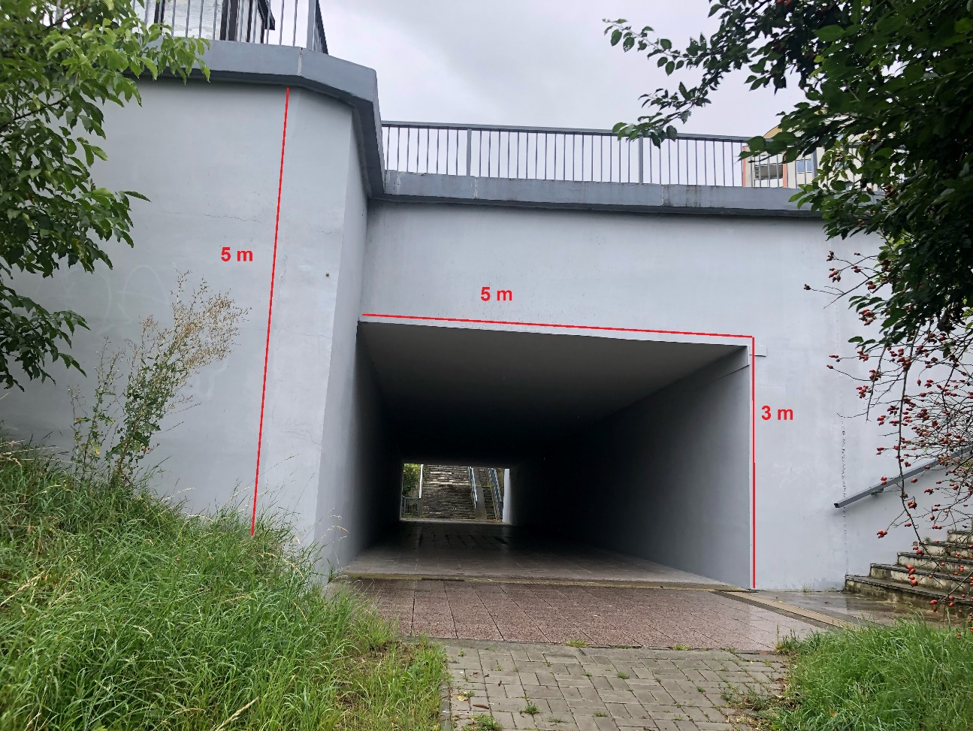

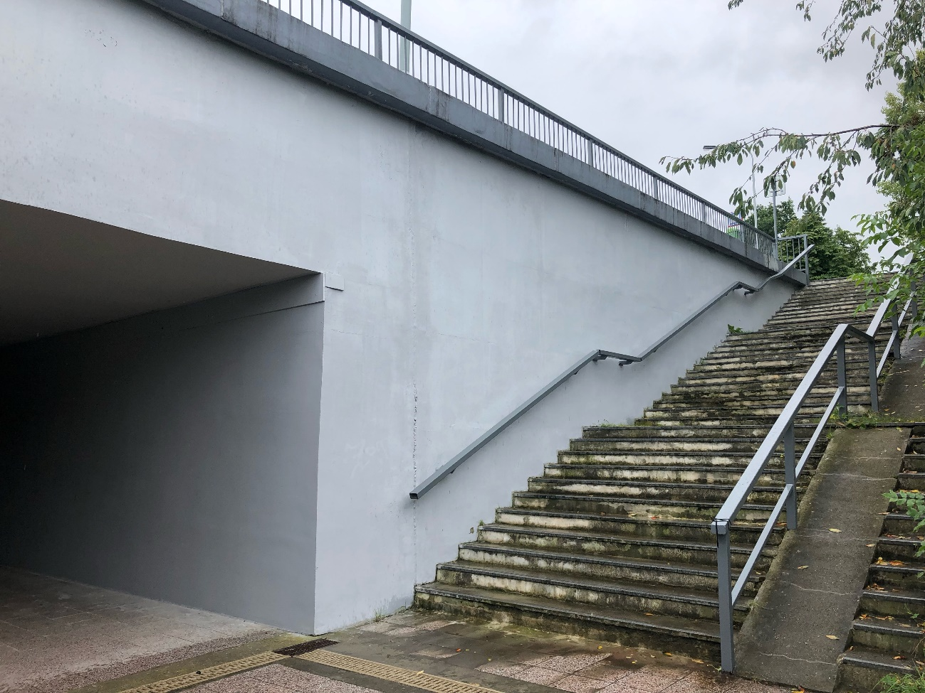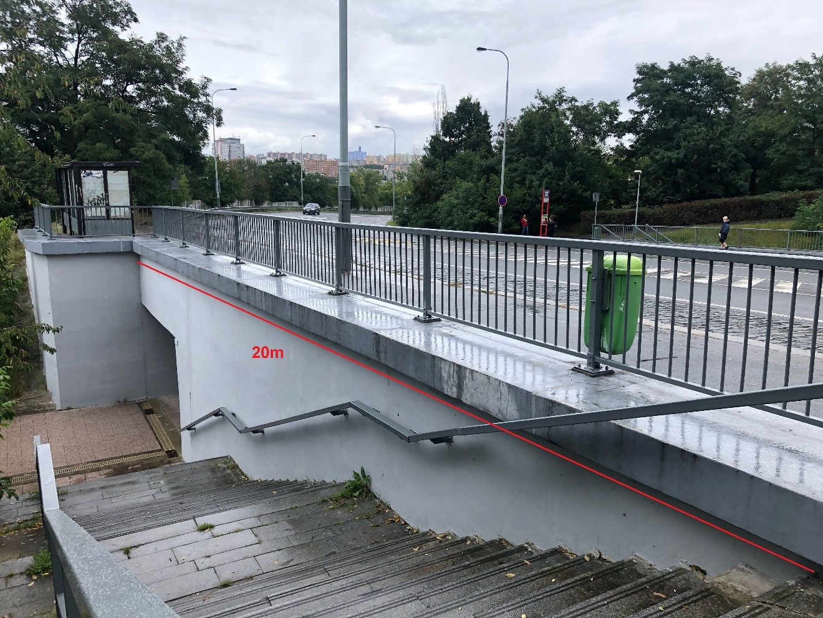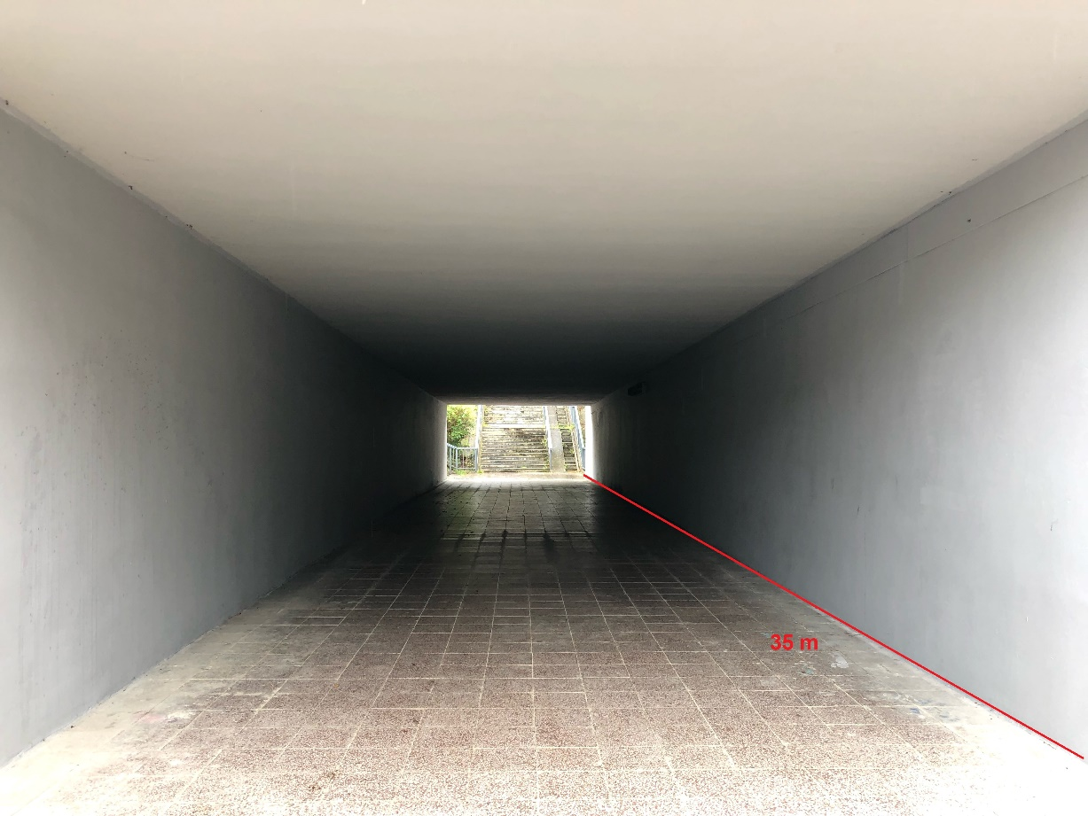

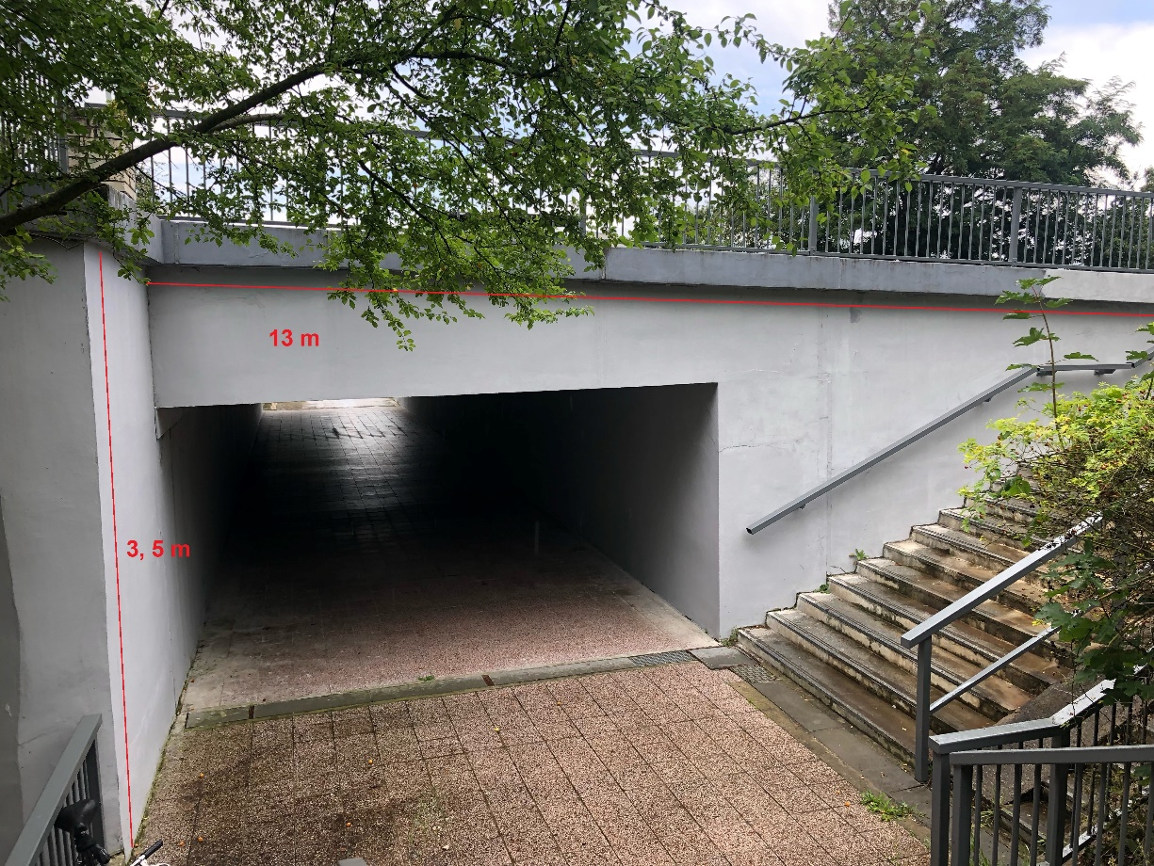

Rewards:
- 1st place – 20,000 Czk
- 2nd place – 15,000 Czk
- 3rd place – 10,000 Czk
- Artistic concept of the whole subway on Svatojánská Street, Prague 14.
The subway near the Rajská zahrada underground station connects the quiet residential area with the housing estate Černý most I under the busy Chlumecká Street. The front wall can be partially used too, unlike the whole outdoor wall near the parking lot.

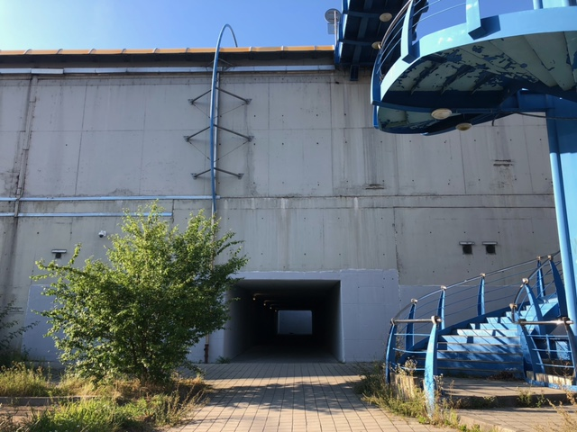

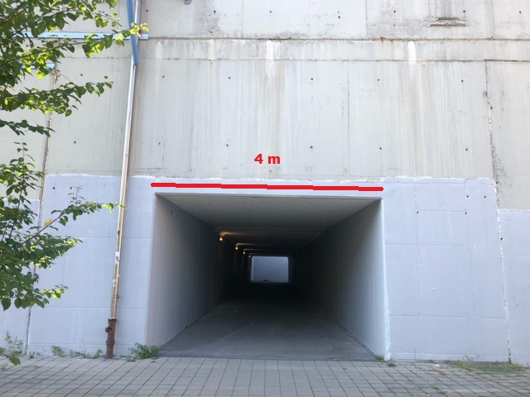
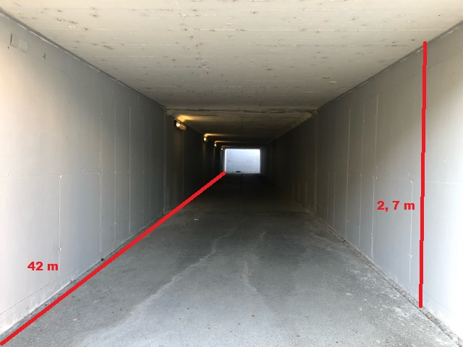

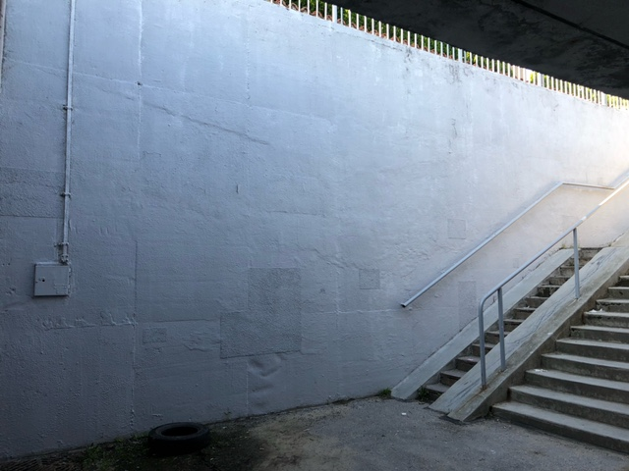
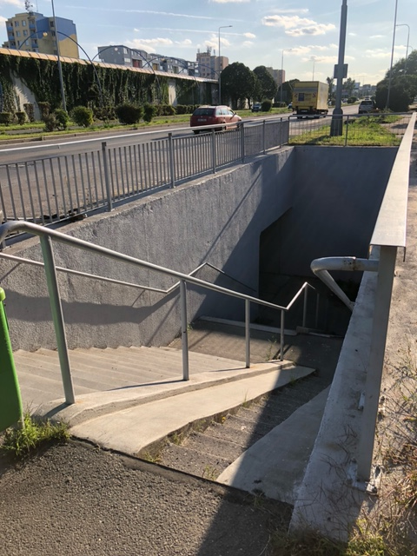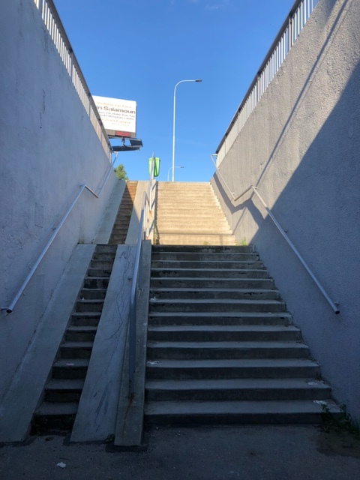

Rewards:
1st place – 20,000 Czk
2nd place – 15,000 Czk
3rd place – 10,000 Czk

- Artistic concept of the whole subway under Makovského Street, Prague 17.
The subway under Makovského Street is located at the heart of the Řepy housing estate, offering interactions with pedestrians walking from the tram stops, between the blocks of flats, and the busy street. The front wall is an architectural artwork in its own right so it needs not be included in the project, yet the artwork can overlap to it.

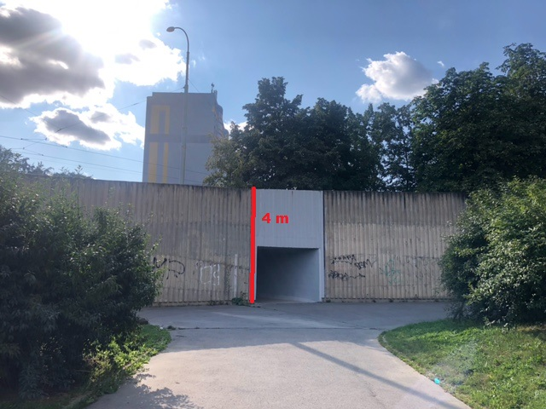
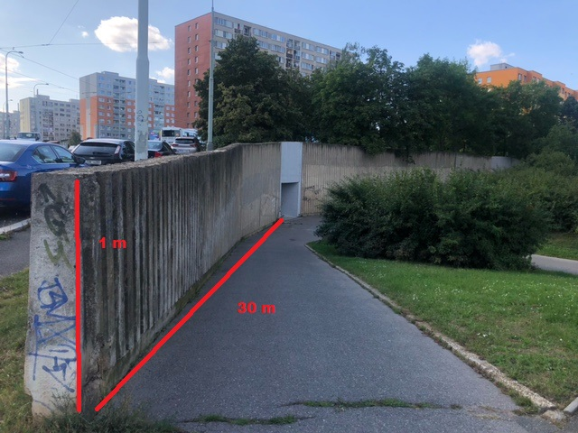
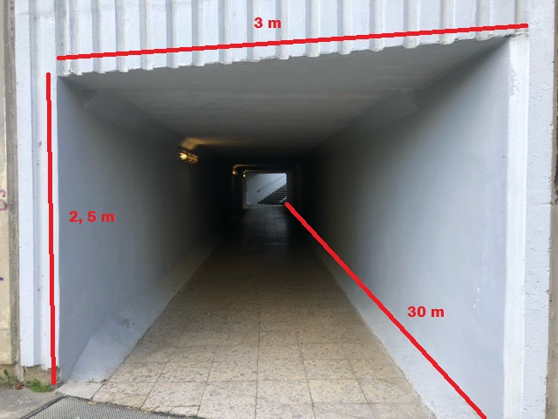

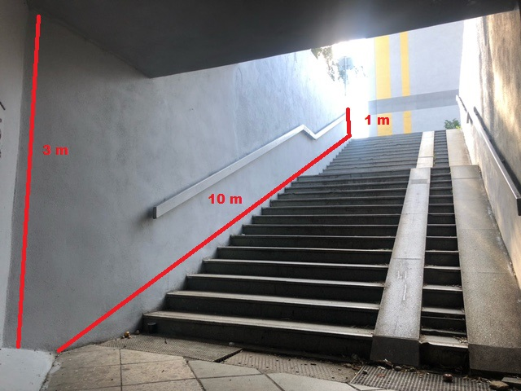
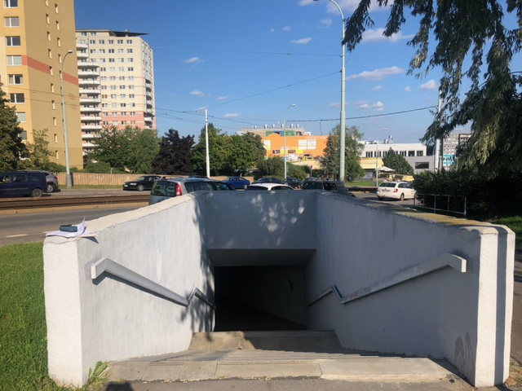

Rewards:
1st place – 20,000 Czk
2nd place – 15,000 Czk
3rd place – 10,000 Czk

- EVALUATION CRITERIA:
- Originality of the artwork (artistic quality and benefit, communication skills of the artwork, author’s concept)
- Local context (use and understanding of the location including historical, cultural and social context)
- Feasibility (respect to the local limits, rules and safety measures, and to people in the public space)

- ANNOUNCEMENT OF THE RESULTS:
The winning and awarded proposals will be announced on October 14, 2021, on the website https://umenipromesto.eu.
  - The Prague City Gallery considers the submitted projects binding. The Prague City Gallery also reserves the right to withdraw from the competition in case of insufficient number of applicants. In case of poor quality of the proposals, the Prague City Gallery reserves the right to refuse the realization. The proposals submitted within the deadline, including the required attachments, will be assessed by the Committee consisting of art theoreticians, curators, architects, artists experienced in street art and murals, and representatives of the Prague City Hall, city districts and location owners. There is no appeal possible against the decision of the Committee.
  - The lineup of the Committee will be published on the website of the project “Art for the City”: https://umenipromesto.eu until September 20, 2021.
  - A written record will be made the meeting of the Committee, including the list of all evaluated artworks and the verdicts. The record will include the list of all attending Committee members, and the evaluation of the projects. The meeting of the Committee isn’t publicly accessible.
- CONTACT INFORMATION:
  - In case of any questions, please feel free to contact us at umenipromesto@ghmp.cz and anna.gumplova@ghmp.cz
  - You can also arrange for a personal consultation via e-mail, or ask for details regarding the conditions, or for assistance in making the presentation.
- Important dates:
  - Announcement of the call: September 6, 2021
  - Deadline for proposals: October 6, 2021 (until 12 AM)
  - Announcement of the results: October 14, 2021

